**Python Programs**

1)WAP with Function fizz_buzz where there'll be a single argument [Number].

Rules for Output :

1. If the number is divisible by 3: print out 'Fizz' [3,6,9 etc]

2. If the number is divisible by 5: print out 'Buzz' [5,15,20 etc]

3. If the number is divisible by both 3 and 5: print out 'FizzBuzz' [15,30 etc]

4. If None of them is satisfied, then print the number itself. [2,4,7 etc]

2)WAP to find out Days of a Month using function which will take in two arguments : year, month number.

* days_in_month(2017, 8) -> Find the Number of Days in August[8th Month of the Year] in Year 2017 == 31
* days_in_month(2020, 2) -> Find the Number of Days in February[2nd Month of the Year] in Year 2020 == 29

3) Write a Python program to check "Can someone of the given age and citizenship status run for president in the US?"

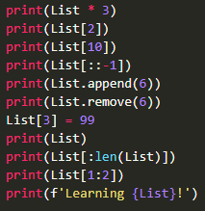

Answer the Following Questions :

**4)Answer These!**

You're given a List :